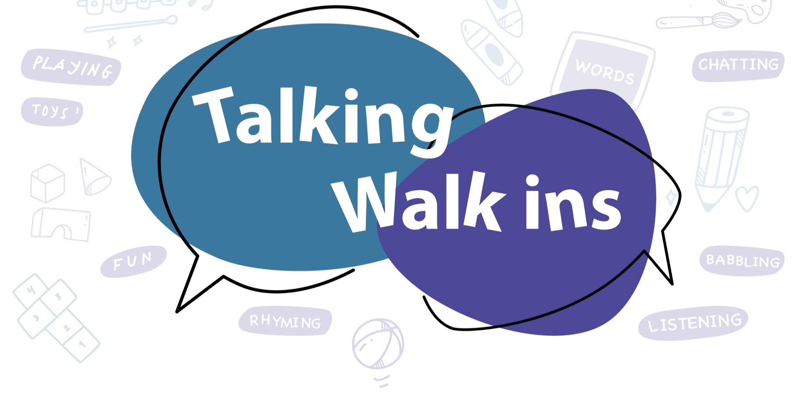

Ashford

Concerned about your pre-school child’s speech, language or communication skills?
Talking Walk-ins are play-based drop-in sessions where you can speak to a speech and language therapist or other staff.
Just turn up – no need to book!
If the session is very busy, it might not be possible for everyone to speak to a speech and language therapist. On these occasions you can speak to one of our assistants who can signpost you to an alternative date if needed

These sessions are only for families with pre-school-aged children. The service also runs in other parts of Kent.

Family Hubs | Day/session
The Willow Family Hub, Brookfield Road, Ashford, Kent, TN23 4EY Tel: 03000 418800 | 1st Thurs of month Time: 9.30-11:00am  3rd Friday of the month 1.30-3.00pm
Waterside Family Hub, Turner Close, Ashford, Kent, TN24 0PQ Tel: 03000 418700 | 3rd Weds of month Time: 1.00-2.30pm
Bockhanger Family Hub, Belmont Road, Kennington, Ashford, Kent, TN24 9LS Tel: 03000 418600 | 4th Monday of month Time: 9.30-11.00am
Tenterden Family Hub, Recreation Ground Road, Tenterden, Kent, TN30 6RA Tel: 03000 418400 | 5th Wednesday of the month  (when occurs) Time: 1.00-2.30pm


They run in school holidays, but not on Bank Holidays or between Christmas and New Year. Check the Ashford Family Hubs Facebook page for updates.
Talking Walk-ins provide you with advice or ideas to try at home. We may signpost you to other support or invite you to a follow-up with the speech and language therapy service.

