Y6 SATs

May 2021

Information for Parents

Year 6 End of Key Stage 2 Tests

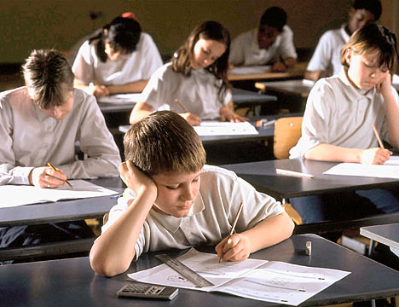
SATs, or Standard Assessment Tests, are the former, but still held to, name for National Curriculum Tests. These are statutory end of key stage tests in two of the core subjects of the National Curriculum; English and Mathematics.

On all test papers they are shown how many marks each question is worth: one, two or three. This should help them know how much effort to put into answering each one. For example a ‘one mark’ answer often only requires one word, while a ‘three marker’ may need two or three sentences.

Papers are sent away for independent marking and returned to the school. The staff check the papers for accuracy of marking and tallying the marks as mistakes have been found in the past.

National Curriculum Levels are awarded as follows:

- PK – Pre Key Stage
- HNM – Has not met the expected standard (This won’t be used for writing)
- WTS – Working towards the expected standard
- EXS – Working at the expected standard
- GDS – Working at a greater depth

A score of just over half the available marks
will usually achieve expected level.

On leaving primary school, our children will move onto secondary school and the Key Stage 3 curriculum. Children who have achieved at Key Stage 2 will have built a good foundation on which to continue to learn.

All parents/carers receive a report that states what level their child achieved in each of the three core subjects, in both the results of the tests and the teacher assessments. We usually share these results with the children.

Using this information, the secondary schools will be able to provide for continuity in each child’s education in Year 7.

English
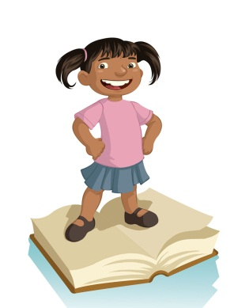
There are three tests:

- Reading

The children will have one hour to read three stories or poems or nonfiction writing, and some information writing broadly based on a theme such as ‘The Olympics’ or ‘Weather’ and then answer a range of questions in written answers. Answers can be in phrases and don’t often have to be in full sentences.

The questions range from the literal (who does what, when) to the deductive (where, for example, they have to work out how someone is feeling from what is written). Your child will be encouraged to say which parts of the text contained the answer and will need to include examples.
- English grammar, punctuation and spelling

An English grammar and punctuation test will take place – children given 45minutes to complete questions involving all the areas of grammar and punctuation. With spellings a teacher will read out the a text twice and on the second time through children will have to fill in the gaps using the correct spellings.

These will be externally marked.

Maths

There are three maths papers. The papers include calculating skills, understanding of shapes, symmetry and reading charts.
- The first paper has a range of problems from straight calculations to practical examples (such as working out how many cakes fit on a tray).

- The second and third papers have a heavy focus on reasoning. The children are NOT allowed to use calculators.

In all of these papers, children are encouraged to show how they arrived at an answer. Marks are awarded for showing working out, even if the answer is wrong. Children will also be expected to show an understanding of how to use and apply their mathematical knowledge in a variety of ways or ‘to think like a mathematician’.
- Children who need questions read to them will be assigned a reader, scribe or amanuensis (both reader and scribe) depending on their needs.

- If a child’s writing is hard to read, work (or parts of it) will be transcribed.

This will be externally marked.

How else can you help?

SATs can be a worrying time for your child and can lead to nervousness as the tests approach. Good coping strategies include:

- Reassure them that they just have to try their best on the day.
- Teach them how to relax by breathing deeply and closing their eyes to picture a calm scene like a green field by a river.
- Keep an early and regular bedtime routine in the days leading up to and including the test week – no later than 8.30 p.m.!
- Remind them that in most parts of the SAT papers, children do not have to write in sentences: often, phrases or even single words will be enough.
- Ensure your child has breakfast every day, especially during the week of the tests. Research shows that children who miss breakfast perform worse in late morning.

The tests are carried out in familiar surroundings with as much sensitivity as it is possible, mainly in the school hall, although some children will work in classrooms or work areas around the school. The lead invigilator will be the class teacher.

Everything will be done to help your child feel at ease and to allow them to give their best.

